Effective Delegation & Empowerment

Delegation: Assigning specific duties and responsibilities to an individual.

Empowerment: Enabling team members to set work goals, make decisions, and solve problems within their sphere of responsibility and authority.

**|| Why delegate and empower? ||**

* Leaders understand that they must work through others and gain leverage.
* Many leaders, particularly entrepreneurs, fail to let go of control and try to do too many things themselves.
* Buy-in requires creating a feeling of ownership through delegation and empowerment.
* Competency as a leader involves developing the competency of others.
* Inspires the team.

**|| General tips ||**

1. Ask yourself: What is the best use of your time? Delegate any task or projects that are not the best use of your time wherever possible.
2. Reflect: Are you a player, a player-coach, or a coach? As a senior leader, you ideally should primarily be a coach.
3. When a problem occurs on a project you have delegated, give the employee a reasonable chance to work it out for themself rather than taking it back.
4. Consider how the assignment will help employees develop their knowledge, skills and expertise.
5. Balance the level of authority and support you give the person with experience of the employee.
6. Start with small, low-risk tasks and build up from there.
7. When an employee brings a question or problem to you, ask: “What would you recommend?” This helps share responsibility for addressing the problem, encourages them to bring solutions, and conveys that their opinion is valued.

**|| 6 Steps to effective delegation ||**

1. Prepare before you delegate a task or area of responsibility.
2. Clearly define the task to be completed. Be specific. Ask the person to whom you are delegating to repeat the information back to you to ensure that they fully understand.
3. Clearly outline the time frame within which the delegated task is to be completed.
4. Define the level of authority they are to use with this task.

Level 1: The authority to recommend: They research options and propose the best solution. You use the recommendation to make a final decision.

Level 2: The authority to inform and initiate: They research, explain the best course of action, then initiate selection of an option. Use this approach when you want to be informed of the proposed approach before they act.

Level 3: The authority to act: assigning full ownership of the task, project, area of responsibility.

1. Identify checkpoints when you will meet with the individual to review progress and offer guidance, if needed. Schedule these meetings frequently at first, taper off as you see the task being mastered.
2. Hold a debriefing session to discuss what went well, what could have been improved, and what has been learned.

**|| Selecting level of authority ||**

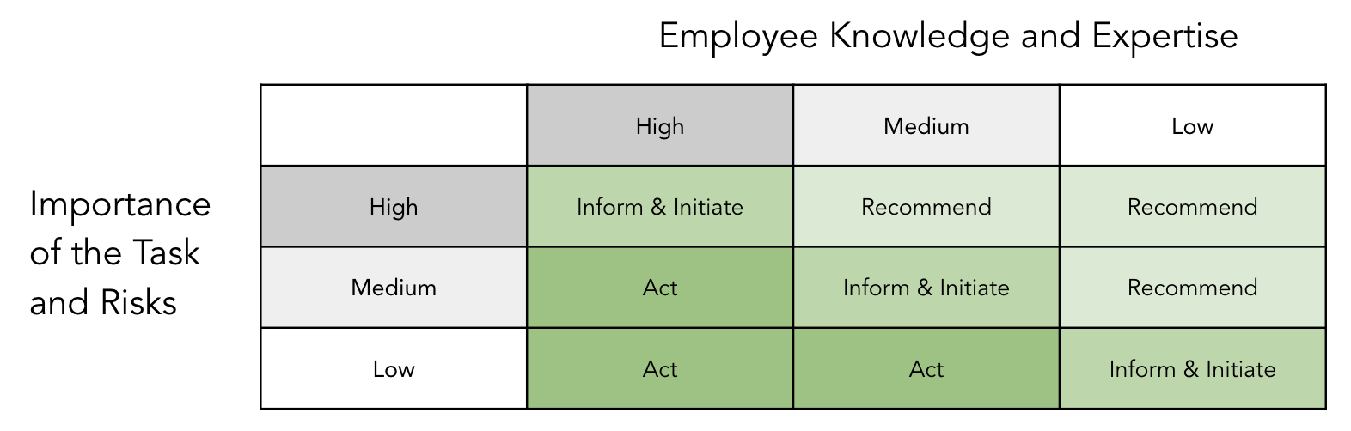

Reference: Donna M. Gennet. *If You Want It Done Right, You Don’t Have to Do It Yourself! The Power of Effective Delegation.*